CONTENT FOR WEBSITE

LANDING PAGE

WELCOME MESSAGE:  
It is a matter of great pride and honour for an Educational Institute when the grandaunts spread their wings and take flight into the infinite sky of career opportunities. CVRCE displays a conviction that old students are priceless possessions and valued emissaries as they have added sheen and lustre to the glory of the institute and raised the banner of our college higher. In order to foster and strengthen the bond between the alma mater and the alumni, the college has registered Alumni Association during the year 2007 with the Regd # 486. The department level Alumni groups are invoked and the Alumni that are spread across the Globe are allured to join the alumni network. To coordinate all the alumni activities the college has constituted this Alumni Affairs division involving faculty members from each department

**SLIDESHOW PHOTOS**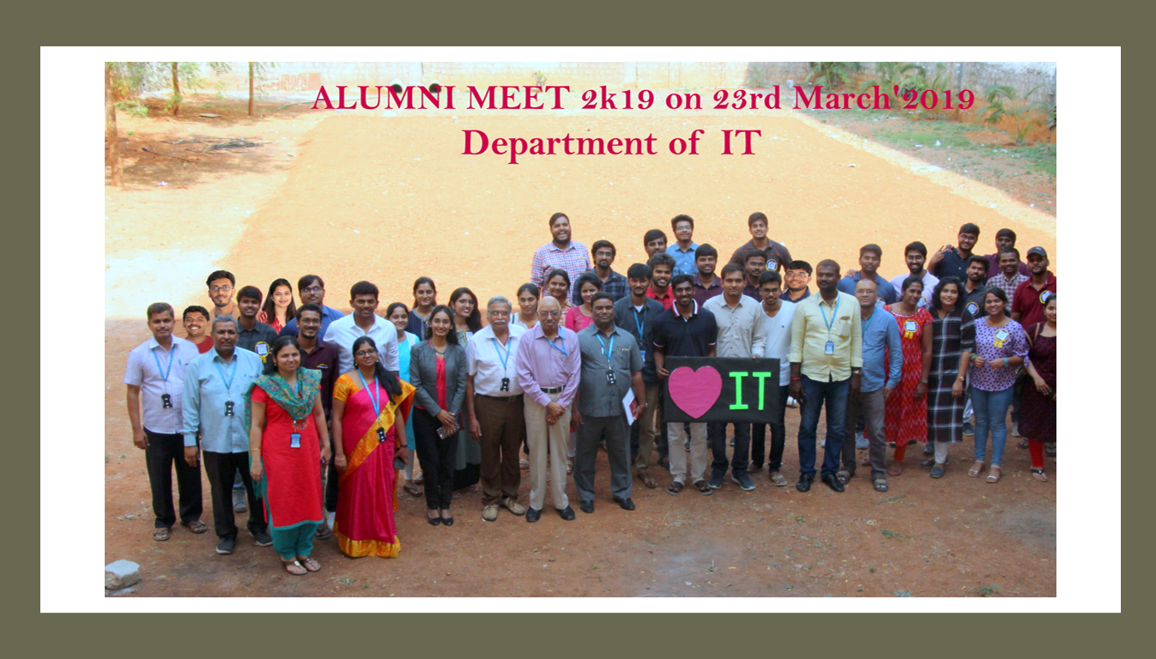

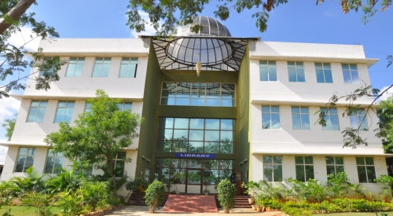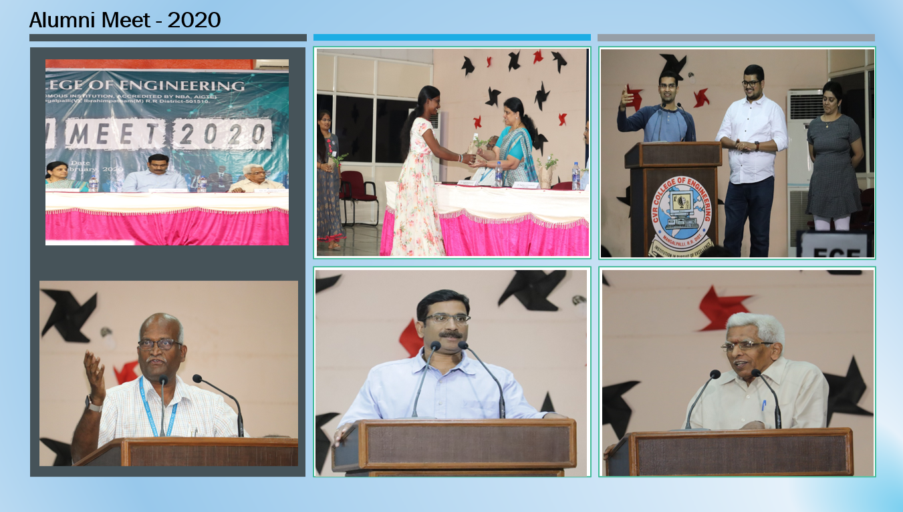 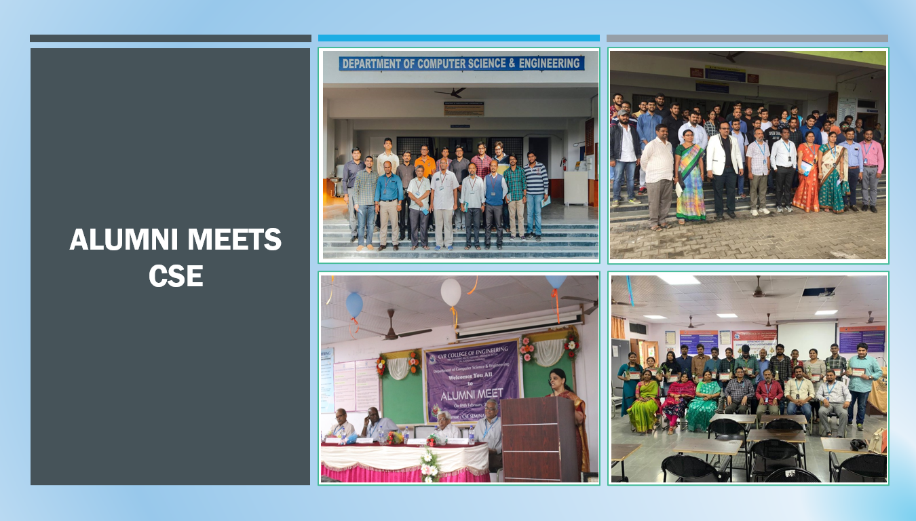

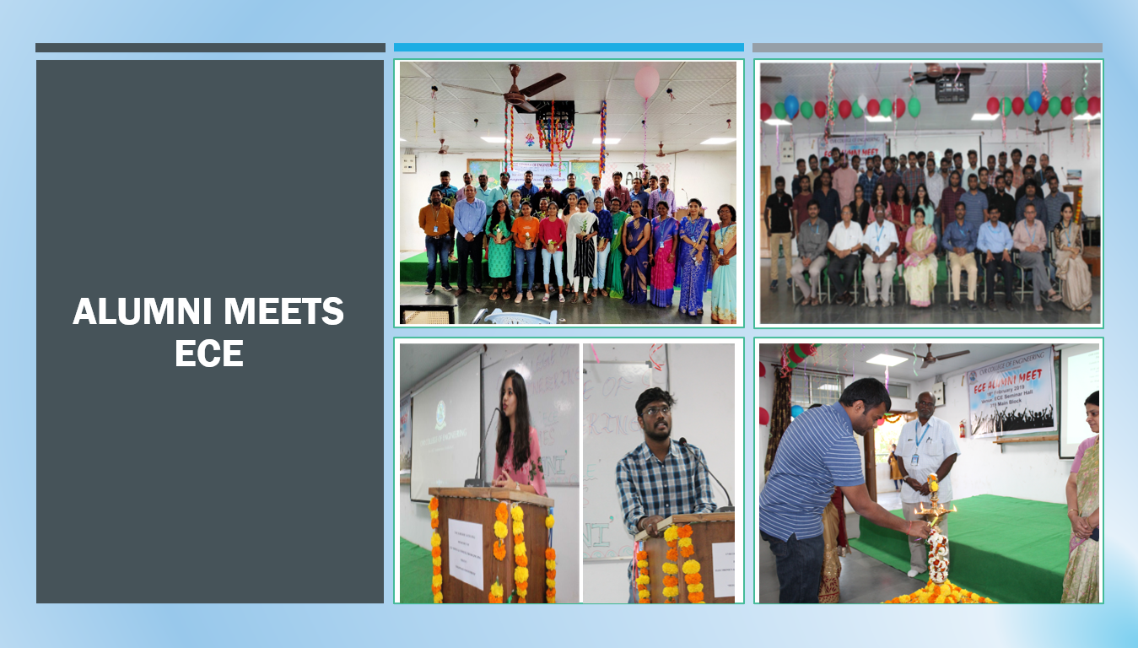

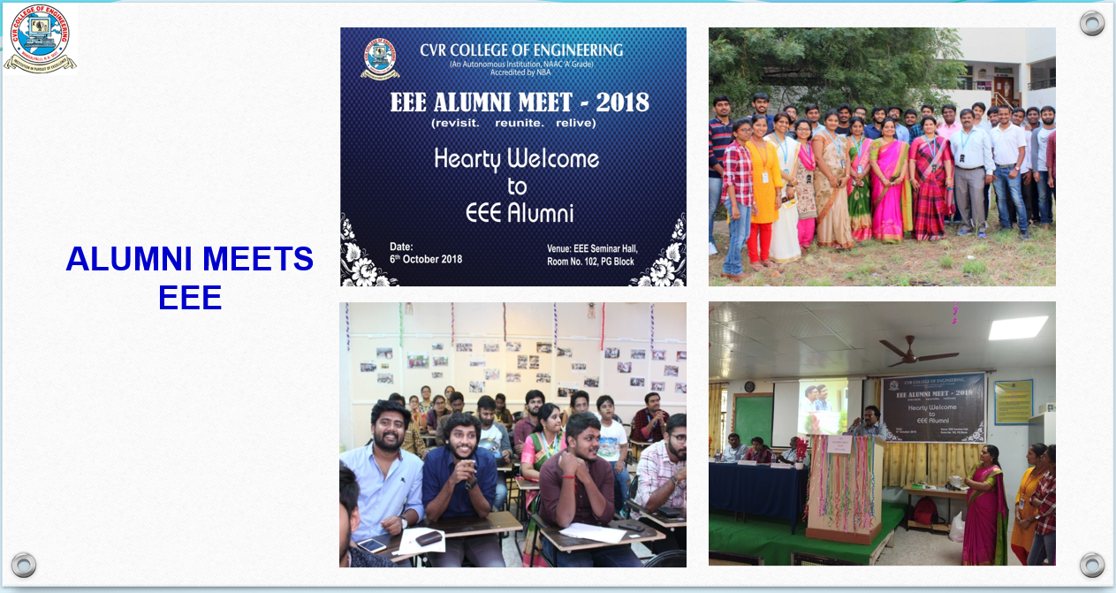

**UPCOMING EVENTS**

*** Photos will be placed in the future

ILLustrious Alumni

** Information and pictures will be taken from the alumni (Wall of frames)

NEWS & STORIES



DATE: MAY 7,2021

**Private engineering colleges witness jump in campus placement**

There is a huge demand for students who are trained and certified in resources such as Full Stack ,JAVA, Salesforce ,Font-end engineering etc. Due to rise in good offers, the average salary in our institution has increased from Rs 4.90 lakh to Rs 6 lakh this year,” said Vijaya Mair, head campus and corporate relations of CVR College of Engineering.

**EVENTS**

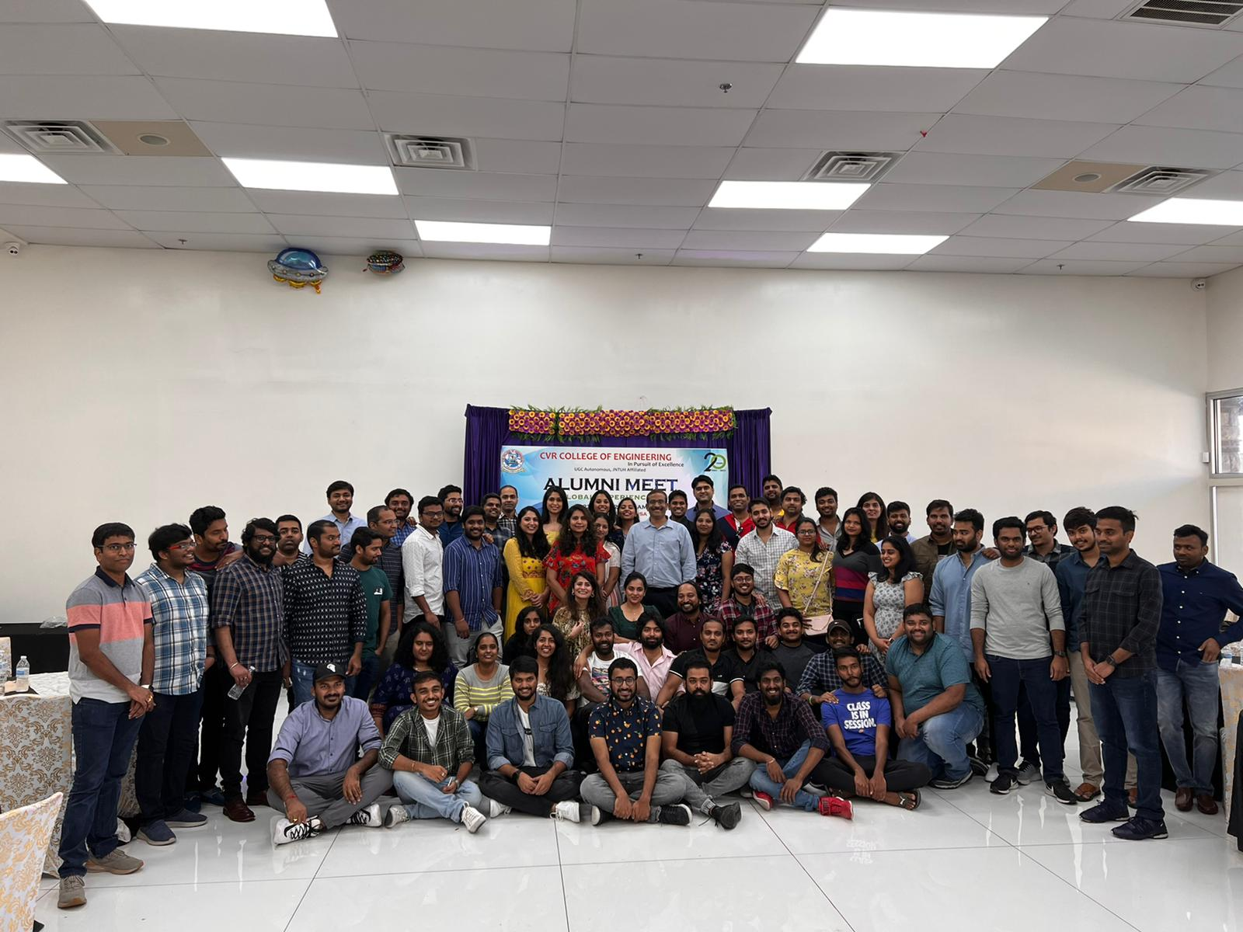

**23 OCT 2021**

**DALLAS ALUMNI REUNION**

**PAST EVENTS**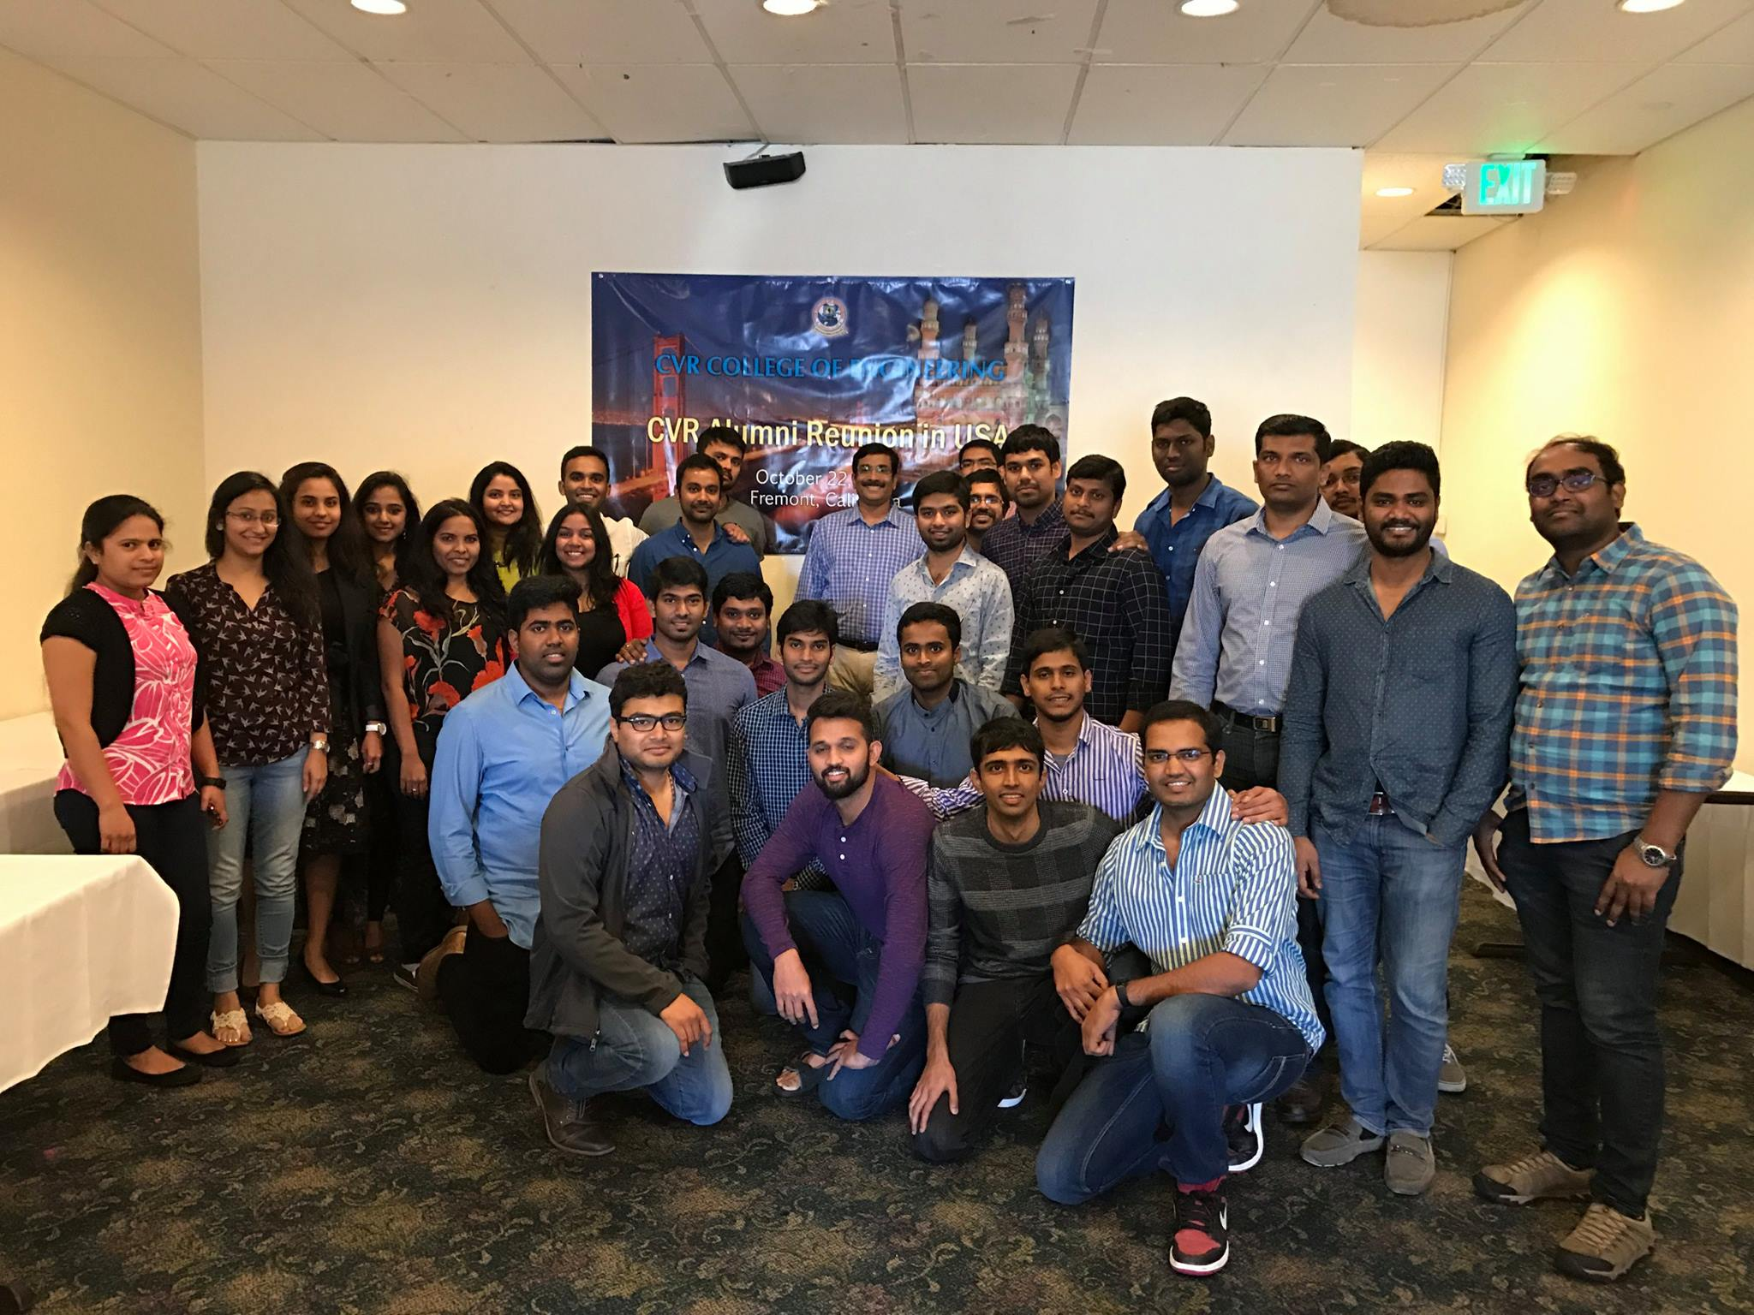

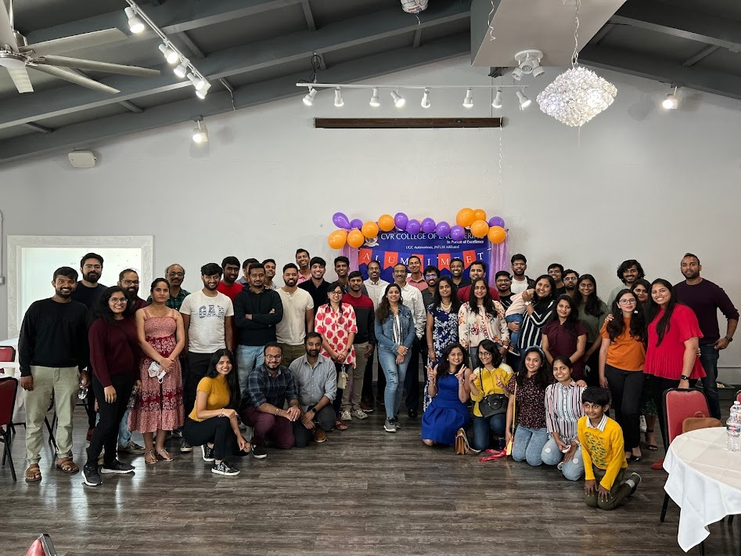

**ALUMNI ACHIEVEMENTS**

